DEV TEA PARTY WEBSITE

**Introduction**

Report by: Aleksandrs Lukjanovs Student Number: M00674847

To Whom It May Concern,

This is a progress report for the website. The website’s focus is on giving voice to those who are not always heard. More specifically it will focus on proving support to developers of either ANIME or GAMES by providing each respective community with a space for them to be heard. If I had to give a similar example it’s like Reddit but, very specific and more controlled. Also, actually recognizing devs of popular enough ANIME or GAMES.

**Why Anime or Games?**

I chose these topics for purely personal reasons being, I just love anime and games. In fact, many people really love those too. But these are the areas that I feel need a little bit of a voice so developers can be closer to their community by pulling for ideas from them. Or to put it one sentence, I just feel like it.

# **Website**

**Description**

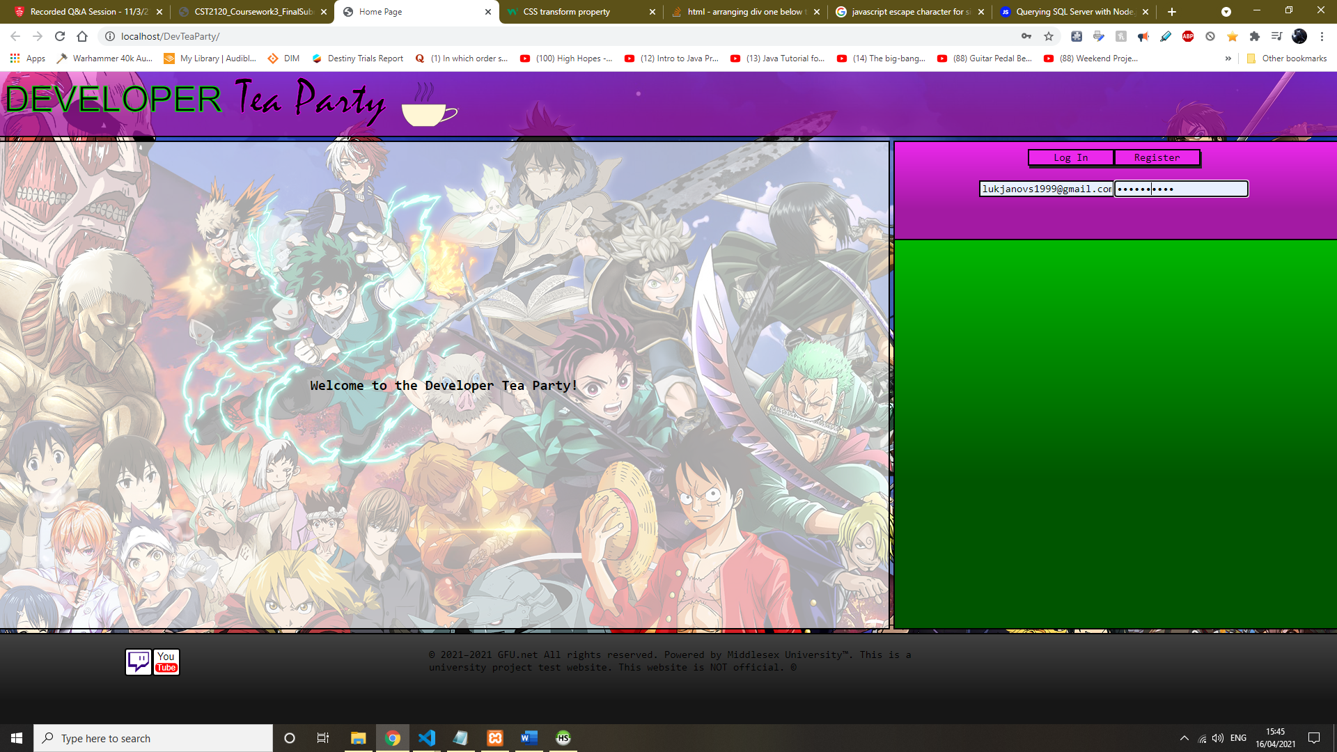

This is the only web page. It was still work in progress.

The colours are meant to be bright and clean going for the anime aesthetic. The buttons are simple and clean. This design is attempting to blend transparency and a lot of different colours without being too irritating. Not much else besides that.

* Some attempt was made to try and get registration working.

**Development Overview**

Development sadly did not go as expected main cause of which was lack of time. However, if you look at this from a different perspective a fair amount of work was done for the time available. Key features were implemented demonstrating that the concept is plausible and works. For the most part the development was smooth.

**Planning**

Fair amount of planning went into this project to get the job done. A lot of notes was made and a lot of ideas thought of. Some drawing. For the most part fairly basic planning.

**Database**

The database was partially implemented only using features that are implemented such as comments, posts, registration, and log in. Originally the database was designed with some additional ideas.

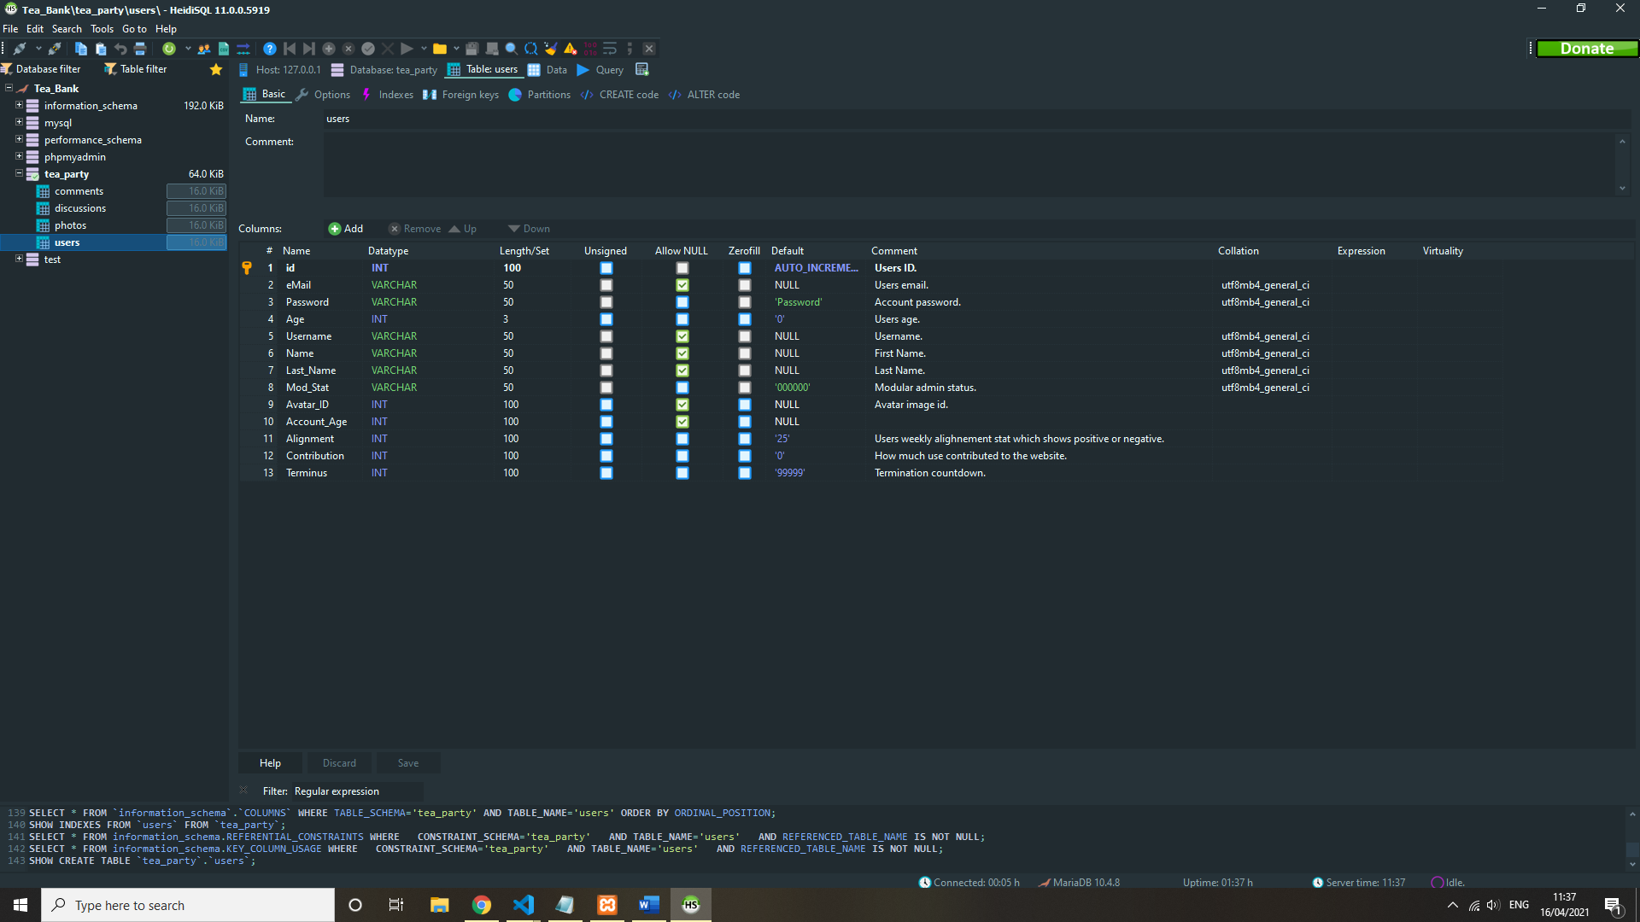 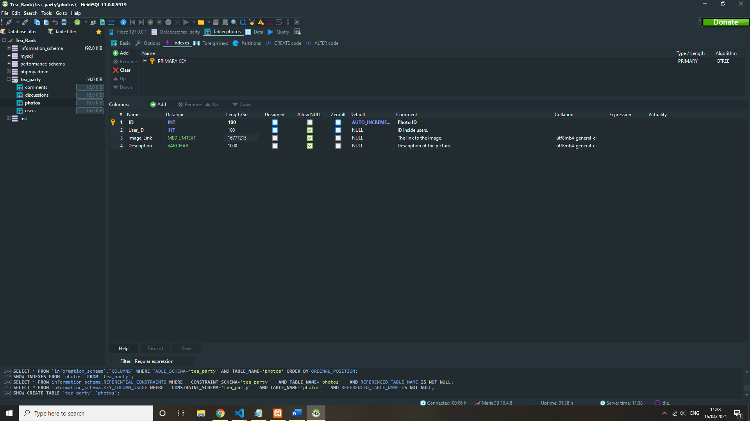

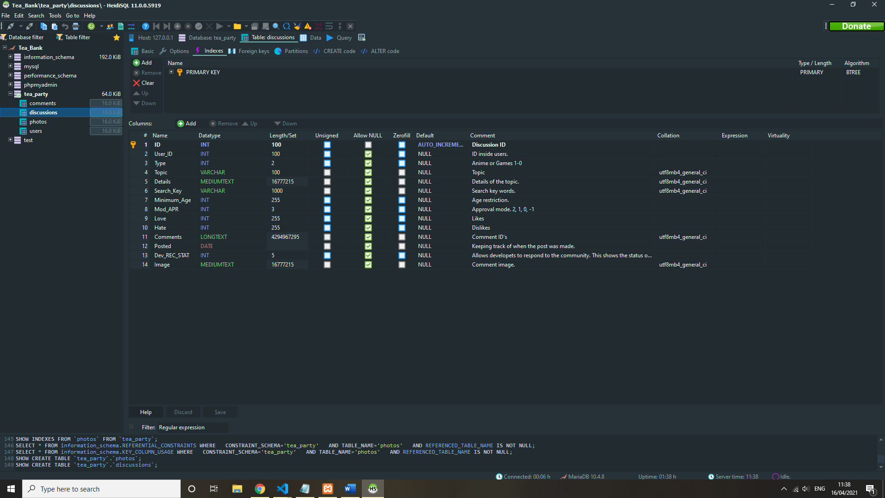

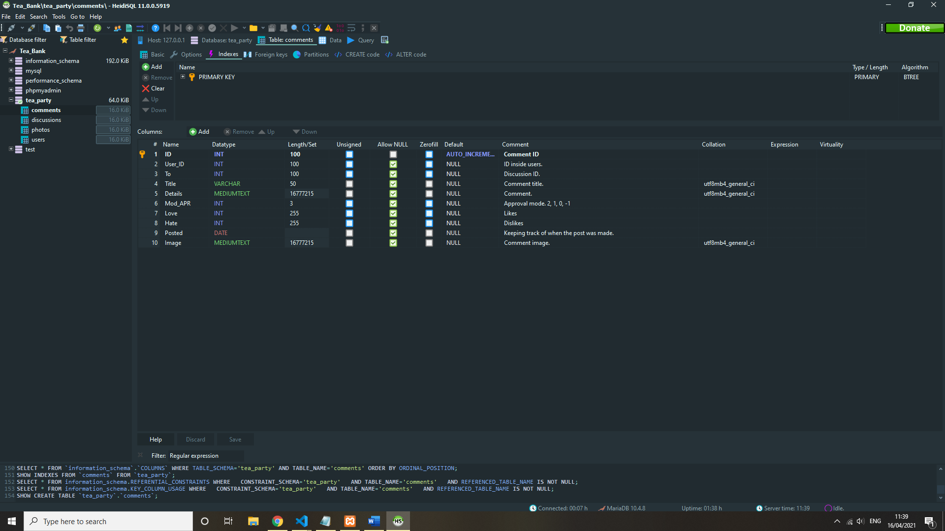

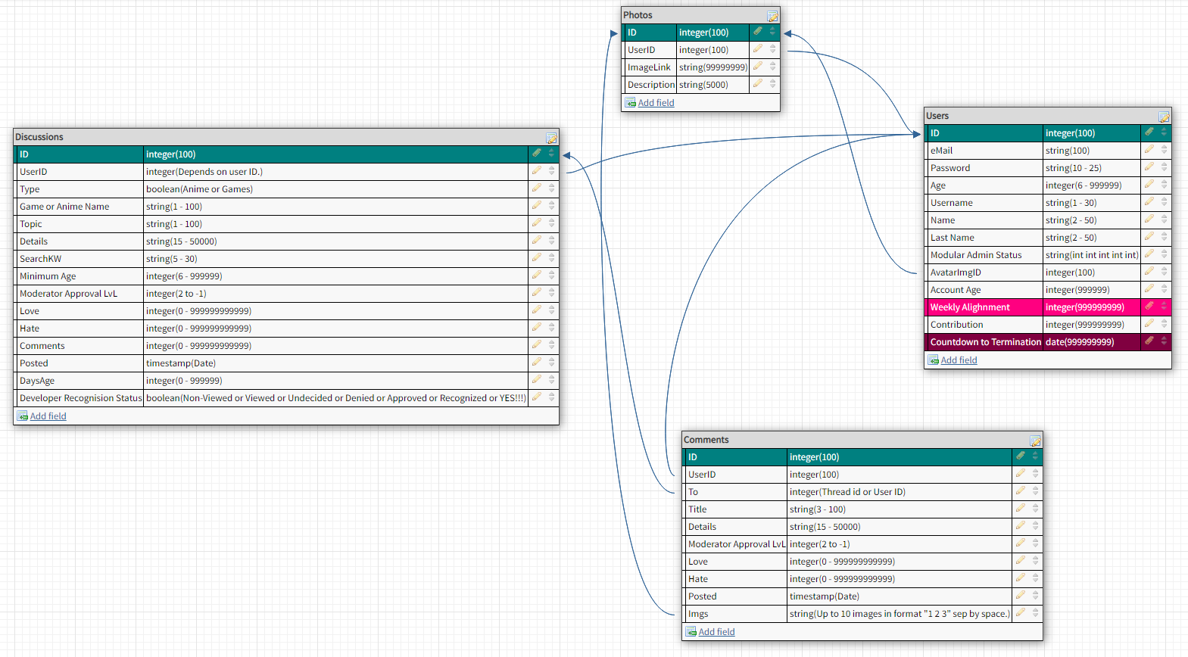

**Improvements**

Project could be improved with better time management and a bit more foresight.